Ratings:

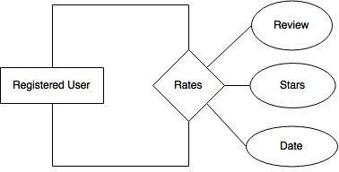

We decided to create the table User_ratings for this urinary relationship. There are three attributes we created for this table: Stars, Date, and Review. We made sure the primary key was the UID (user ID). We made Stars and Date NOT NULL because for every review, we wanted everyone to give a specific number of stars for the user and as well as an actual date of review. The Review would be written and because of that we made it the TEXT data type be- cause it could be very long. Having looked at sites such as Amazon and EBay, we found that some reviews didn’t have any text and just a star rating. We decided to also adopt this idea, and that is why our Review’s are nullable.

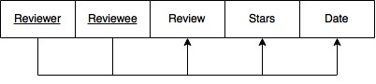

CREATE TABLE User_ratings (

reviewer CHAR(20),

reviewee CHAR(20),

review TEXT,

stars INT NOT NULL,

date DATE NOT NULL,

PRIMARY KEY (reviewer, reviewee),

**User_rating:**

FOREIGN KEY (reviewer) REFERENCES RegisteredUsers (username),

FOREIGN KEY (reviewee) REFERENCES RegisteredUsers (username),

|  |  |  |
| --- | --- | --- |
|  |  | ON DELETE CASCADE |
| ); |  | |
|  |
|  |
|  |
|  |
|  |
|  |
|  |
|  |
|  |
|  |
|  |
|  |
|  |
|  |
|  |
|  |
|  |
|  |
|  |
|  |

Sale Item:

We created 3 separate tables for this ISA relationship: Items, Sale_Items, and Auction_Items. We made a lot of the fields NOT NULL because we wanted exact numbers and values for items, prices, and times. The whole auctioning process is very dependent on the time and prices be- cause they can change all the time.

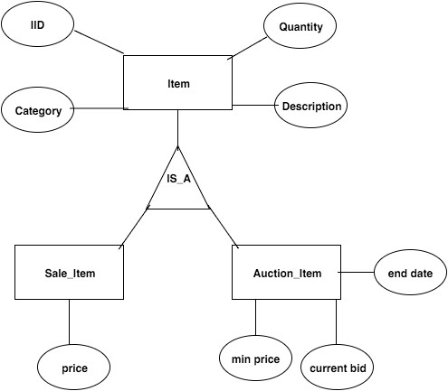

**Items:**

|  |  |  |  |
| --- | --- | --- | --- |
| IID | Quantity | Category | Description |

**Sale_Items:**

IID price

**Auction_Items:**

|  |  |  |  |
| --- | --- | --- | --- |
| IID | min_price | current bid | end date |

CREATE TABLE Items (

IID CHAR(40),

quantity INT NOT NULL,

category CHAR(30),

description TEXT,

PRIMARY KEY (IID),

FOREIGN KEY (category) REFERENCES Categories (name)

);

CREATE TABLE Sale_Items (

IID CHAR(40),

price FLOAT NOT NULL,

PRIMARY KEY (IID),

FOREIGN KEY (IID) REFERENCES Items (IID)

ON DELETE CASCADE

);

CREATE TABLE Auction_Items (

IID CHAR(40),

end_date DATE NOT NULL,

min_price FLOAT NOT NULL,

current_bid FLOAT,

PRIMARY KEY (IID),

FOREIGN KEY (IID) REFERENCES Items (IID)

ON DELETE CASCADE

);